

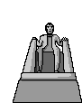

Class of 20010-2013 is invited to

go on the Ferguson school field trip to
Washington DC/NewYork (8 days)
Week of April 4th, 2010
Register before
September30
2009
Please contact Mr. Marshall at dmarshall@dadeschools.net
Room 1246 in Building 12

